|  |
| --- |
| US Department of Labor  office of Labor-management standards |
| CBA Registration & Disclosure |
| Functional Requirements |
| Release v1.0 |
|  |

**Revision History**

|  |  |  |  |
| --- | --- | --- | --- |
| **Date** | **Revision** | **Description** | **Author** |
| **09/08/2020** | **1.0** | **Initial Draft** | **Bineeta Adityan** |
| **09/22/2020** | **1.0** | **Initial Draft Review** | **Christopher Wiederkehr** |
|  |  |  |  |

**Contents**

1. Backgroud 1

2. Project Description 1

3. Definitions, Acronyms, Abbreviations 1

4. References 2

5. FUNCTIONAL REQUIREMENTS 2

5.1. Login 2

5.2. Default Page 2

5.3. Letter and CBA Registration 3

5.3.1. Letter Listing 3

5.3.1.1.1. Sort and Column filter 4

5.3.1.1.2. Field Level Requirements 4

5.3.1.2. Add New Letter (manually) 6

5.3.1.3. Import Process 7

5.3.1.3.1. Import data requirements 7

5.3.1.3.2. Import Data file 8

5.3.1.4. New Employer 9

5.3.1.5. New Union 9

5.3.2. CBA Letter 10

5.3.2.1. Signature 10

5.3.3. CBA Letter Editor 10

5.3.3.1. Send Initial Notification 10

5.3.3.1.1. Email letters 10

5.3.3.1.2. Print F7 letters 10

5.3.4. Other Functions on the Letter Page 11

5.3.4.1. Mark as Mail Returned 11

5.3.4.2. Mark as Email Returned 11

5.3.5. Export 11

5.3.5.1. Letter Editor 11

5.3.5.2. Edit Employer 12

5.3.5.3. Edit Union 12

5.3.6. CBA 12

5.3.6.1. Review and Publish Page 14

5.3.6.2. Un-publish or republish a CBA 15

5.3.6.3. CBA Listing Page 16

5.3.6.4. Send an Expiration Notice 17

5.3.6.5. Print Expiration Notice 17

5.3.6.6. Export 17

5.3.7. OPDR Display 18

5.3.8. Reports 18

5.3.8.1. Statistics Report 18

5.3.8.1.1. Statistics Report – Export 18

5.3.8.2. Counts By Month – Report 19

5.3.8.2.1. Counts By Month Report– Export 19

6. Requirements Revisions History 19

# Backgroud

In May 2007, Secretary Chao issued Secretary’s Order 4-2007, authorizing the Department of Labor’s Collective Bargaining Agreements to be transferred to the Office of Labor-Management Standards (OLMS) from the Bureau of Labor Statistics (BLS).

The Division of Reports Disclosure and Audits will be responsible for collecting, registering, maintaining, and finally publishing the Collective Bargaining Agreements files on the OLMS website. The DRDA staff contacts the Employer or Labor Union requesting an updated copy of their current collective bargaining agreement. Employer/Unions sent the CBAs by mail or by email. Current CBA registration requires the following manual steps:

* Enter the CBA details in a spreadsheet (tracker (CBA Tracker (FY 2020).xlsx).
* Enter the same information in the ESAKDatabase (Access database) to get the OLMSK#.
  + Every new entry will get a new OLMSK#.
  + Manually identify the private and public CBAs.
    - Private CBAs will get a four-digit K number, and public CBAs will get a six-digit K number.
  + Manually identify the NAICS # for Employers who have not provided this information.
* Enter the CBA into the respective grid in the Dreamweaver application.
* Enter the CBA in the Access Database stored in the Y drive.
  + There are three Access databases in this location.
  + The user will enter the CBA data in the Main database (OLMS CBA Postings National Office.accdb).
  + The updated data will be exported to the other two access databases.
* Finally, the user send the notification to the OLMS IT staff to update the links in the CBA postings and have OPA post the changes.

# Project Description

Since the current process requires many manual, tedious steps, the management decided to create a new registration tool OLMS Content Management System (OCOMS), to easily register and disclose the CBA files.

The following Web contents will be registered and published on the OLMS’ disclosure site, Online Public Disclosure Room (OPDR).

• FOIA Letters

• OLMS Weekly Reports

• CBAs

This new tool will allow the OLMS users to send notifications to the Employers/Unions, to receive and register the CBA files and finally publish the CBA file on the OLMS Disclosure page.

# Definitions, Acronyms, Abbreviations

The following is a list of commonly used acronyms used throughout this document:

| Term | Definition |
| --- | --- |
| CBA | Collective Bargaining Agreement |
| OCOMS | OLMS Content Management System |
| DOL | Department of Labor |
| OLMS | Office of Labor-Management Standards |
| FOIA | Freedom of Information Act |
| FMCS | Federal Mediation and Conciliation Service |

# References

* ESAKDatabaseOLMS.mdb
* OLMS_CBASearchTool.laccdb
* CBA Instructional Guide
* F7 Notice Spreadsheet

# FUNCTIONAL REQUIREMENTS

The initial release of OCOMS will include only the CBA registration sections. This document covers the functional requirements for registering and disclosing the Collective Bargaining Agreements (CBA) submitted to OLMS by companies and Unions. The application will be available only to the internal OLMS users, however the application will allow CBAs to be disclosed in the OPDR application on the OLMS internet site.

# Login

OCOMS’ initial entry point will be the login page. A mock-up is listed below:

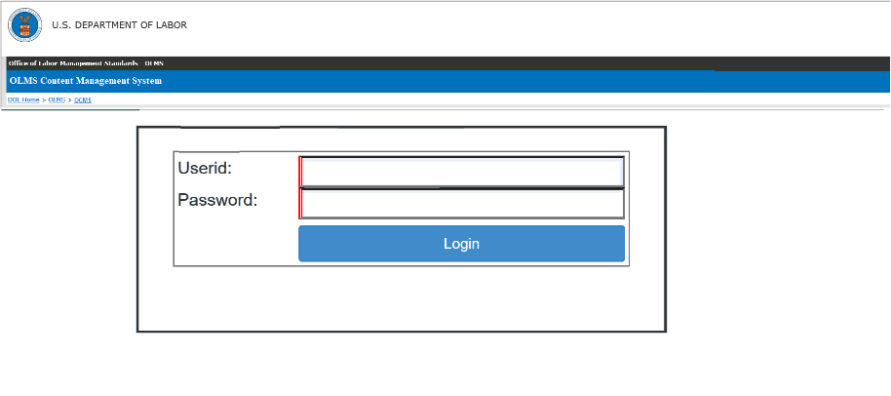

# Default Page

Upon a successful login, the system will display the DOL disclaimer pop-up. Upon accepting the pop-up the user will be navigated to the following page:

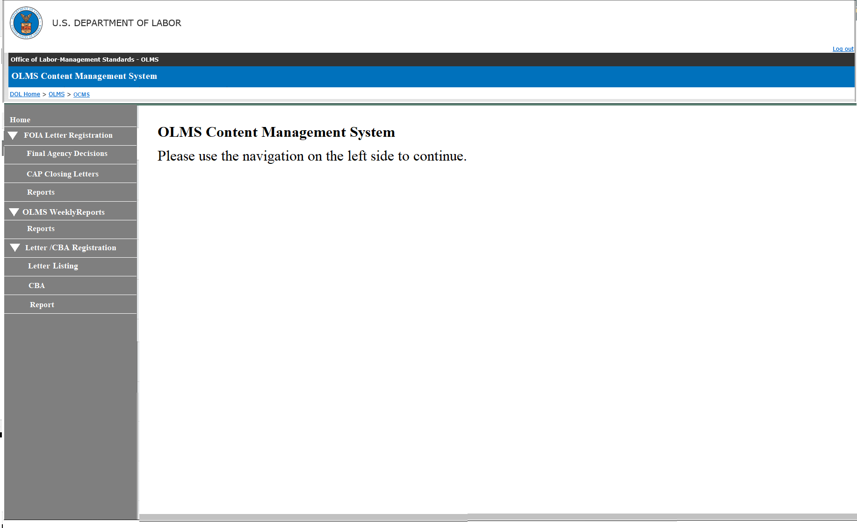

# Letter and CBA Registration

The system will have the following sections to create Leter records, register and disclose CBA and generate management reports. The section will have the following pages:

* Letter Listing
* CBA
* Reports

# Letter Listing

Clicking the Letter Listing link will open the Letter listing page. A mock-up design is displayed below.

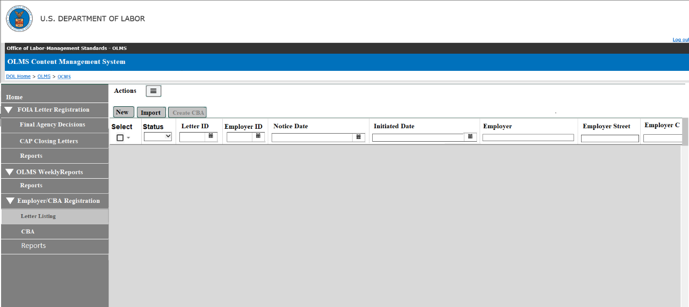

# Sort and Column filter

Each column will have a sort, and column filter added. The user should be able to use one or more column filters. Additional column filter requirements are contained in the field level requirements section.

# Field Level Requirements

**Status –**The status of each Letter will be listed in this field. The following are the different statuses. The column filter for this field will be a drop-down list to pick one status.

* **New –** Newly created Employers will have this status.
* **Initial Notice Sent –** The Employer who received the letter via email will have this status.
* **Initial Letter Printed –** The Employers who received the mail will have this status.
* **CBA Received –** The Employers who have the CBA registered, but not published.
* **CBA Published -** The Employers who have the CBA registered and published on OPDR.
* **Mail Returned –** The user will set this status if the mail is returned (probably the mail address is wrong).
* **Email Returned -** The user will set this status if the email is bounced.
* **Expiration Notice Sent –** The expiration letter sent from the CBA page will have this status.
* **Expiration Letter Printed –** The expiration letter generated from the CBA will have this status

**Letter ID –** This column will list the unique identifier for each letter. The column filter will allow the user to search for any particular Letter ID.

**Employer ID** – This column will list the unique identifier for each Employer. The column filter will allow the user to search for any particular Employer ID.

**Notice Date** – This column will list the Notice Date of the letter. The format will be YYYY-MM-DD. This field will have a date range column filter.

**Initiated Date** – This column will list the Initiated Date of the letter. The format will be YYYY-MM-DD. This field will have a date range column filter.

**Employer Name** - This column will list the name of the Employers. The user should be able to use a full or partial name to filter the list.

**Employer Street** – This column will list the Employer's street address. The user should be able to use a full or partial address to filter the list.

**Employer City** – This column will list the city. The user should be able to use a full or partial city name to filter the list.

**Employer State** – This column will list the state. The column filter sbould be a dropdown list to pick a state.

**Employer ZIP** - This column will list the Zip Code.

**Employer Representative** – This column will list the name of the Employer’s representative’s first and last name. The user should be able to use a full or partial name to filter the list.

**Employer Rep Phone** – This column will list the phone number.

**Employer Rep Title** – This column will list the title. The user should be able to use a full or partial title to filter the list.

**Employer Rep Email** – This column will list the email address. The user should be able to use a full or partial email to filter the list.

**Union ID -** This column will list the unique identifier for each Union. The column filter will allow the user to search for any particular Union ID.

**Union**– This column will list the Union name or Union abbreviation. The user should be able to use a full or partial Union name to filter the list.

**Union Designation** – This column will list the designation. The system should list the list multiple Union’s designations with a separator (slash (/), comma (,), ampersand (&)). The user should be able to use full or partial Union designations to filter the list.

**Union Local Number** – This column will list the Union local identifier. The system should list multiple Union’s local number with a separator (slash (/), comma (,), ampersand (&)). The user should be able to use a full or partial Union local number to filter the list.

**Union Street** - This column will list the Union’s street address. The user should be able to use the full or partial address to filter the list

**Union City** - This column will list the city. The user should be able to use the full or partial city to filter the list.

**Union State** - This column will list the state. The column filter should be a dropdown list to pick a state.

**Union ZIP** - This column will list the Zip Code.

**Union Representative** - This column will list the Union representative’s first and last name. The user should be able to use a full or partial name to filter the list

**Union Rep Phone** - This column will list the phone number.

**Union Rep Title** - This column will list the title. The user should be able to use a full or partial title to filter the list.

**Union Rep Email** - This column will list the email address. The user should be able to use a full or partial email to filter the list.

**Affected Location City** - This column will list the location city. The user should be able to use a full or partial city name to filter the list.

**Affected Location State** - This column will list the state. The column filter should be a dropdown list to pick a state.

**Affected Location ZIP** - This column will list the Zip Code.

**Expiration Date** - This column will list the expiration date for the CBA. The format will be YYYY-MM-DD. This field will have a date range column filter.

**Industry** – This column will list the industry name. The user should be able to use a full or partial name to filter the list.

**Bargaining Unit Size** - This column will list the number of people in the bargaining unit. The user should be able to enter a minimum and maximum number to filter the list.

**Establishment Size** - This column will list the establishment size. The user should be able to enter a minimum and maximum number to filter the list.

**Notice Submitted By** – This column will list the source for the F7 notice. Give some examples of source.The user should be able to enter full or partial text to filter the list..

**Category** – This column will list the category of each Employer. The user should be able to enter full or partial text to filter the list.

**Healthcare Related** – This column will list Y and N. The column filter should be a drop-down list.

**Created Date** – This column will list the date in which the Employer was created. The format will be YYYY-MM-DD. This field will have a date range column filter.

**Email Sent Date** – This column will list the date in which the F7 letter is emailed to the Employer. The format will be YYYY-MM-DD. This field will have a date range column filter.

**Letter Print Date** – This column will list the date in which the F7 letter is printed. The format will be YYYY-MM-DD. This field will have a date range column filter.

# Add New Letter (manually)

When creating a letter, the system should provide the following data fields:

**Letter ID –** Initially, this field will be blank and will be read-only. Upon save, the system will generate a unique identifier.

**Notice Date –** This will be a date field. The format will be YYYY-MM-DD.

**Initiated Date** – This will be a date field. The format will be YYYY-MM-DD.

**Affected Location City -** This will be a data field to enter the city.

**Affected Location State –**  This will be a drop-down field to select the state.

**Affected Location ZIP** - This will be a numeric field in 5 (xxxxx) or 5+4 format (xxxxx-xxxx)

**Expiration Date -** – This will be a date field. The format will be YYYY-MM-DD.

**Industry –** This will be a text field to enter the Industry listed in the CBA agreement**.**

**Bargaining Unit Size –** This will be a numeric field to enter the unit size.

**Establishment Size -** This will be a numeric field to enter the establishment size.

**Notice Submitted By –** This column will text field to enter the source for the F7 notice**.**

**Category –** This will be a text field to enter the category of each Employer.

**Healthcare Related** – This will be a checkbox field to indicate the healthcare related CBA .

**Search feature to associate Employer:** The system will provide a search feature to associate an existing Employer to the letter.

* If the Employer does not exists, the system should allow the user should to create a new Employer manually (section: 5.3.1.4) and then associate it to the letter.

**Search feature to associate Employer/Union:** The system will provide a search feature to associate an existing Employer and Union record to the letter.

* If the Employer/Union does not exists, the system should allow the user should to create a new Employer and Union record manually and then associate it to the letter.

# Import Process

Every month, OLMS receives a CSV file from the Federal Mediation and Conciliation Service (FMCS) agency listing the Unions and Employers for collective bargaining agreements that are about to expire.

The system will have an import process to import the data listed in the spreadsheet.

# Import data requirements

The system will have an import process to import the data listed in the spreadsheet. Additional data requirements listed below:

* The system should ignore the NAICS code listed in the spreadsheet. The NAICS code will be added on the CBA registration page once OLMS receives the CBA agreement file.
* The spreadsheet has one field for Union name, and local number. Import process should split the data to get the Union name, and the local number..
* Union
* Union Designation (if we can find a way to get this information from other fields.)
* Union Local Number
* Every successfully imported Employer record will get a unique identifier, Letter ID.
* The status of each record will be set to **New**.
* The import process will have a duplicate check to identify any duplicate records in the file.
* The Duplicate check will use the combination of the following data elements in the CSV.
* Employer, Employer address, Employer representative, Union, Union address, Union representative, and the industry
* The data has to be an exact match to mark it as duplicate
* If the same data combination already exists in the database (previously created), the application will follow the steps below:
  + - Display the data for the user to review.
    - Provide the optiond below:
      * Remove from the import (the user will choose this option if the data is duplicated).
      * Proceed and import the data (the user will choose this option if the data is not a duplicate).

# Import Data file

The import file should have the following data fields

**Notice Date**

**Initiated Date**

**Employer Name**

**Employer Street**

**Employer City**

**Employer State**

**Employer ZIP**

**Employer Representative**

**Employer Rep Phone**

**Employer Rep Title**

**Employer Rep Email**

**Union**

**Union Designation**

**Union Local Number**

**Union Street**

**Union City**

**Union State**

**Union ZIP**

**Union Representative**

**Union Rep Phone**

**Union Rep Title**

**Union Rep Email**

**Affected Location City**

**Affected Location State**

**Affected Location ZIP**

**Expiration Date**

**NAICS –** This field should be ignored by the system.

**Industry**

**Bargaining Unit Size**

**Establishment Size**

**Notice Submitted By**

**Category** -

**Healthcare Related**

# New Employer

The user should be able to create a new Employer record manually. The following data fields will be available to create a new Employer record.

**Employer ID** – Initially, this field will be blank and will be read-only. Upon save, the system will generate a unique identifier for each Employer.

**Employer Name** - This will be a text field to enter the Employer's name.

**Employer Street** – This will be the address field to enter the Employer's street address.

**Employer City** – This will be the text field to enter the city.

**Employer State** – This will be a drop-down field to select the state.

**Employer ZIP** - This will be a numeric field in 5 (xxxxx) or 5+4 format (xxxxx-xxxx)

**Employer Representative** – This will be a text field to enter the Employer's representative's first and last name.

**Employer Rep Phone** – This will be a field to enter the phone number.

**Employer Rep Title** – This will be a text field to enter the title.

**Employer Rep Email** – This will be a field to enter the email address.

**Include Employer Rep's Email on the F7 Notice** – This will be a check-box field. Checking this box will add the Employer Representative's email address will be included in the F7 Email.

# New Union

The user should be able to create a new Union record manually. The following data fields will be available to create a new Union record.

**Union ID -** – Initially, this field will be blank and will be read-only. Upon save, the system will generate a unique identifier for each Union.

**Union**– This will be a text field to enter the Union name.

**Union Designation** – This will be a text field to enter the designation.

**Union Local Number** – This will be a text field to enter the Union local identifier

**Union Street** - This will be the address field to enter the Union’s street address

**Union City** - This will be the text field to the city.

**Union State** - This will be a drop-down field to select the state.

**Union ZIP** - This will be a numeric field in 5 (xxxxx) or 5+4 format (xxxxx-xxxx).

**Union Representative** - This will be a text field to enter the Union representative’s first and last name.

**Union Rep Phone** - This will be a field to enter the phone number.

**Union Rep Title** - This will be a text field to enter the title.

**Union Rep Email** - This will be a field to enter the email address.

**Include Union Rep’s Email on the F7 Notice** – This will be a check-box field. Checking this box will add the Union Representative’s email address will be included in the F7 Email.

# CBA Letter

The user should be able to select one or more letters from the letter listing to send the CBA letters to the Employers and Unions.

The letter will have Employer ID, Employer name, Employers address, Union information, and the expiration date of the CBA.

# Signature

The system should have an option to allow the selection of the signatory from various DRDA members.

# CBA Letter Editor

The system will provide a formatting capability to edit the text listed in the letter before the letters are printed or emailed.

* The editor should have text formatting capability.
* The editor should have an option to preview the letter.

# Send Initial Notification

The system will support the following notification formats.

# Email letters

The following requirements apply to the **Email Initial Letter** functionality.

* The user should be able to select one or more records from the **Letter Listing** page to print the CBA letter.
* The user should be able to print the CBA letter for each Letter record selected.
  + The letter should have the Employer ID, Employer Name, Address, Union information and the Expiration date printed.
* The status of these records will be changed to the **Initial Notice Sent**.
* The system will also track the **Date Email Sent**.
* The user should be able to resend the letter to the Employers.
  + When resending the letter, the system should track the **Letter Sent Date**.

# Print F7 letters

The following requirements applied to the **Print Initial letters** function:

* The user should be able to select one or more Employers to print the F7 letter.
* The user should be able to print the F7 letter for each Employer selected.
  + The letter should have the Employer ID, Employer Name, Address and the Expiration date printed.
* The status of these records will be changed to the **Initial Letter Printed**.
* The system will also track the **Letter Print Date**.
* The system will track each status, **Email Sent Date,** and **Letter Printed Date** separately for those who have **Email Sent** and **Mail** **Sent**.
* The user should be able to resend the mail to the Employers.
  + When resending the letter, the system should track the **Letter Printed Date**.

# Other Functions on the Letter Page

The Letter Listing page should have the following functions added:

# Mark as Mail Returned

The following requirements applied to the **Mark as Mail Returned** function:

* The user should be able to select one or more letters and **Mark as Mail Returned** option.
* The status for those records will be **Mail Returned.**

# Mark as Email Returned

The following requirements applied to the **Mark as Email Returned** function:

* The user should be able to select one or more letters and **Mark As Email Returned** option.
* The status for those records will be **Email Returned.**

# Export

Users may want to export letter data for personal use. The following requirements apply to the **Export** function:

* The system should provide the following Export options
  + **Export All**
  + **Export Selected**
  + **Export as Filtered**
* The export file should list all data fields listed on the Letter page.

# Letter Editor

The user should be able to open a Letter record to modify the data associated.

* The editor will list all the all fields listed in **section 5.3.1.2**
* In addition to those fields, the editor will list the following fields.
  + **Status** – This will be a read-only field to display the status of the letter.
  + **Created Date** – This will be a read-only field to display the date which the letter was created.
  + **Email Sent Date** – This will be a read-only field to display the email sent date.
  + **Letter Print Date** – This will be a read-only field to display the letter printed date.

# Edit Employer

The user should be able to open an Employer record to modify the data.

* From the Letter listing screen, the user should click on the Employer name to open the editor.
* The editor will list all the all fields listed in **section 5.3.1.4**
* A **Delete** button should be provided to delete the Employer selected.

# Edit Union

The user should be able to open a Union record to modify the data.

* From the Letter listing screen, the user should click on the Union name to open the editor.
* The editor will list all the all fields listed in **section 5.3.1.4**
* In addition to those fields, the editor will list the following fields.
  + **Mark as Mail Returned** – this is a check box field.
  + **Mark as email Returned** – this is a check box field.
  + **Created Date** - This will be a read-only field. This field will display the date in which the Employer record was created
* A **Delete** button should be provided to delete the Employer selected.

# CBA

The following requirements apply to the CBA editor.

* Upon receiveing a CBA agreement from an Employer, the user will select the Letter record from the Letter listing page to create a CBA record.
* An agreement may contain multiple Employers, so the user should be allowed to select one or more Letters from the list.
* The data from the selected letter (Employer and Union information) will be listed on the CBA editor.
  + The editor should list each each Employer and the corresponding Union information separately.

The following fields will be listed on this editor.

**CBA ID** – The system will generate this ID upon save.

**Date CBA Received** – This will be a date field. The user will enter (or select from the calendar pick) this date.

**Employer ID** – The Employer ID will be populated by the system and will not be editable.

**Employer Name** -  The system will populate the Employer's Name.

* The user is allowed to modify the Name of the selected Employer. Upon Save, if the Employer's name is changed, the system will provide a warning message.

The message will be added once approved.

* The system will also provide a search feature to find and replace Employer using any active Employer records saved in the database.
* **Search Employer** – Clicking this button will open a search window to search and pick an Employer to the CBA selected.
  + - Employer's ID and other Employer information will be listed on the editor.
* **Additional** **Employer** – Clicking this button will allow the user to add Employers to the CBA.
  + The system will provide a search feature to find an existing active Employer from the database.
  + If the Employer listed in the CBA agreement does not exist in the database, the system will provide a link to create a new Employer record ( the link will take the user to the Add Employer Page listed in the section **5.3.1.4)**

**Location** – This will be a text field. The user will enter data in this field.

**Union Name** – The system will populate the Union associated with the selected letter.

* The user is allowed to modify the Union displayed. Upon Save, if the Union’s information is changed, the system will provide a warning message.

The message will be added once approved.

* The system will also provide a search feature to find and replace the Union using any active Union records saved in the database.
* **Search Union** – Clicking this button will open a search window to search and pick a Union to the CBA selected.
  + - Union’s ID and other Union information will be listed on the editor.
* **Additional** **Union** – Clicking this button will allow the user to add Unions to the CBA.
  + The system will provide a search feature to find an existing active Union from the database.
  + If the Union listed in the CBA agreement does not exist in the database, the system will provide a link to create a new Union record ( the link will take the user to the Add Union Page listed in the section **5.3.1.5)**

**Union Designation** – The data will be populated by the system and will be editable. The requirements for this field will be the same as the requirements listed for the **Union Name** field.

**Local Number** - The data will be populated by the system and will be editable. The requirements for this field will be the same as the requirements listed for the **Union Name** field.

**NAICS # -** This will be a numeric field. Users will identify the NAICS# for the CBA and enter it here.

**Number of Employees –** This will be a numeric field to enter the number of employees.

**Expiration Date** - This will be a date field. The user will enter (or select from the calendar pick) this date.

**Number of Pages** - This will be a numeric field to enter the number of pages in the agreement document.

**Agreement** **–** This will be a drop-down field listing the values, **Public**, **Private** and **Confidential**.

**Incomplete** – This is a checkbox field. The user will use this to track incomplete CBAs.

**Do Not Publish** – This will be a checkbox field. The following requirements are applicable to this field.

* For the **Confidential** type, this box will be **checked** **automatically**
* Checking this checkbox will stop publishing the CBA on the OPDR page.
* The user will check this checkbox will to stop publishing any CBA on the OPDR page

**Button to browse and upload the agreement file -**  The user will click this button to browse for the agreement saved in the user’s computer to attach it.

**Comment box** – This is a text field to enter any additional information.

**Save** – Clicking this button will save the data entered.

**Cancel** – Clicking this button to close the editor.

**Review and Publish** – Requirements for this button are listed below:

* Upon entering the data set and saving the page, the **Review and Publish** button will be enabled.
* This button will get **enabled** only for the **Private** and **Public** CBAs.
* This button will **not get enabled** when the **Do Not Publish** button is checked.
* Clicking the **Review and Publish** button will open a new page displaying the data entered.

# Review and Publish Page

This will be a preview page for users to review before publishing the data on the OPDR page. The following fields will be listed on this page. All fields will be **read-only** on this page.

**Employer Name** – This field will list the name of the Employer. If multiple Employers are associated, each Employer’s name will be listed with a slash separator.

**View** – This will provide a link to the agreement attached. The user should be able to click and open the agreement.

**Location** – This field will list the location entered.

**Union -**  This field will list the Union name. Multiple Unions will be listed with slash separator.

**Local Number -** This field will list the Union's local number. Multiple Union's local numbers will be listed with slash separator.

**Union Abbreviation -** This field will list the Union abbreviation. multiple Union abbreviations will be listed with slash separators.

**Union Designation -** This field will list the Union designation. Multiple Union designation will be listed with slash separator.

**Expiration Date –** This field will list the Expiration Date entered.

**NAICS -** This field will list the NAICS code entered.

**#Wrkrs -** This field will list the number of workers entered.

**# Pages -** This field will list the number of pages entered.

**Agreement -** This field will list the agreement selected.

**Edit –** Clicking this button, the user should be able to return to the editor for any additional changes**.**

**Cancel –** Clicking this button to close the preview editor

**Publish –** The following requirements applied to this editor

* Clicking this button will instantly publish the CBA data on this page's OLMS disclosure page (OPDR).
* On the Employer page, the status will change to **CBA Received**.

# Un-publish or republish a CBA

The user should be able to edit a CBA after it is published on the OPDR page.

* The user should be able to modify the data for any published CBA and republish it at any time.
* A published CBA can be removed from the OPDR page by checking the check-box **Do Not Publish.**
  + Selecting this check-box and saving should immediately remove the CBA from the OPDR page.

# CBA Listing Page

The following requirements are applied to the CBA Listing Page.

* The page will list all registered CBAs.
* The following fields will be listed on this list screen
* The page should have column filters available on all the columns listed.

**CBA ID** – This column will list the CBA ID

**Employer ID** – This column will list the Employer ID. If more than one Employer is associated with a CBA, this field will list each Employer ID with a slash separator.

**View** - This column will list the link to the CBA agreement document saved in the user’s computer to attach it

**Date CBA Received** – This column will list the date CBA received.

**Employer Name** - This column will list the Employer. If more than one Employer is associated with a CBA, this field will list each Employer’s name with a slash separator.

**Location** – This column will list the location.

**Union Name** - This column will list the name of the Union associated with the CBA. If more than one Union associated with a CBA, this field will list each Union’s name with a slash separator.

**Local Number** - This column will list the local number of the Union associated with the CBA. If more than one Union associated with a CBA, this field will list each Union’s local number with a slash separator.

**Union Abbreviation** – This column will list the Union abbreviation for the Union associated with the CBA. If more than one Union associated with a CBA, this field will list each Union’s abbreviation with a slash separator.

**Union Designation** – This column will list the designation of the Union associated with the CBA. If more than one Union associated with a CBA, this field will list each Union’s designation with a slash separator.

**NAICS # -**  This column will list the NAICS code associated with the CBA.

**Number of Employees –** This column will list the number of employees.

**Expiration Date** - This column will list the expiration date.

**Number of Pages** - This column will list the number of pages in the agreement document.

**Agreement** **–** This column will list the Agrement type of the CBA. ( **Public**, **Private** and **confidential**.)

**Incomplete** – This column will list the Y of the checkbox is checked. If not checked the field will list N.

**Do Not Publish** – This column will list the Y of the checkbox is checked. If not checked the field will list N.

# Send an Expiration Notice

The user should be able to send expiration notices by selecting one or more CBAs.

* The user will select the expired CBA to send the notice to the associated Employer(s) and Union(s).
* The system will create a new letter ID (using the Employer(s) and Union(s) associated with the selected CBA) when generating an expiration letter for the CBA selected.
* This expiration letter will be added to the letter listing page
  + The system will use the CBA letter template to send the expiration notice.
  + This letter will have a status of **Expiration Notice Sent**.

# Print Expiration Notice

The user should be able to print expiration notice by selecting one or more CBAs.

* The user will select an expired CBA to print the notice for the associated Employer(s) and Union(s).
* The system will create a new letter ID (using Employer(s) and Union(s) associated with the selected CBA) when generating an expiration letter for the CBA selected.
* This expiration letter will be added to the letter listing page
  + The system will use the CBA letter template to send the expiration notice.
  + This letter will have a status of **Expiration Letter Printed.**

# Export

The system should provide the following Export options

* Export All
* Export Selected
* Export as Filtered

# OPDR Display

The following requirements apply to the OPDR CBA search page.

* A new page will be added to the OPDR Page.
* All fields listed on the **Review and Publish** page will be listed on this new page.
* The page should have a filter option to filter **Public**, **Private** or **Both**
  + Selecting the **Private** option should list only Private CBAs.
  + Selecting the **Public** option should list only Public CBAs,
  + Selecting the **Both** option should list both Private and Public CBAs.
* The data format should be the same as the **Review and Publish** page.

# Reports

The Reports’ tab will have the following report pages listed.

* Statistics
* Counts By Month

# Statistics Report

The statistics page will list the counts of each CBA type registered during the time frame selected. The following types of CBAs and their counts based on the date range that the user selected should be listed.

* **Private CBAs** – The count of the CBAs with agreement type selected as Private.
* **Public CBAs** - The count of the CBAs with agreement type selected as Public.
* **Confidential CBAs** - The count of the CBAs with agreement type selected as Confidential.
* **Incomplete CBAs** - The count of the CBAs marked as incomplete.
* **Initial Notice Sent** - The count of the letters with the status as **Initial Notice Sent**.
* **Mail Returned** - The count of Employers that have **the Mail Returned** flag checked.
* **Expiration Notice Sent** - The count of the letters with the status as **Initial Notice Sent**.
* **Total counts**

# Statistics Report – Export

The user will be able to export the data corresponding to each count to an Excel spreadsheet.

The export files for the Private CBAs, Public CBAs, Confidential CBAs, Incomplete CBAs and Duplicate CBA counts will list all the following data fields.,

* Employer
* Location
* Union
* Local
* Expiration Date
* NAICS
* #Wrkrs
* Type

The export files for the Email Sent, and Mail Returned will list all the following data fields.

* Employer Name
* Employer Street
* Employer City
* Employer State
* Employer ZIP
* Employer Representative
* Employer Rep Phone
* Employer Rep Email

# Counts By Month – Report

The Counts By Month Report will provide a monthly registration counts of each CBA type. Based on the Begin and End Date entered, the page lists the data by month and the total count.

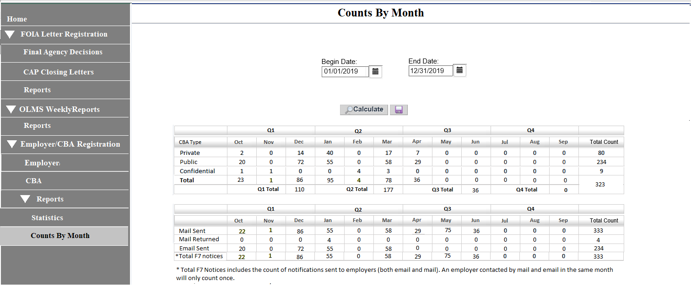

# Counts By Month Report– Export

The user will be able to export this page to an Excel spreadsheet.

# Requirements Revisions History

Meeting minutes for the review meetings are listed below:

| **Date** | **Stakeholders Involved** | **Meeting Minutes** | **Comments** |
| --- | --- | --- | --- |
| **06/18/2020** | Andrew Auerbach  Terry Thomas  Andrew Davis  James Haskins  Avieon Morgan |  |  |
| **07/13/2020** | James Haskins  Avieon Morgan  Henry Kalinowski  Jomica Becknell |  |  |
| **08/11/2020** | Andrew Auerbach  Andrew Davis  Terry Thomas  James Haskins  Avieon Morgan  Michael Delaney |  |  |